CCC HOUSE
11A WEST HALKIN STREET
BELGRAVIA
LONDON, SW1

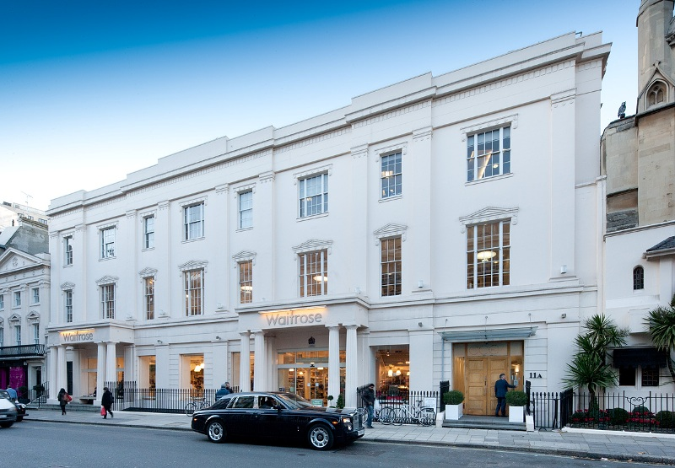

SPECTACULAR AIR CONDITIONED OFFICES

Approx. 10,349 sq ft (961.42 sq m)

TO BE LET

Location: CCC House is located on the north side of West Halkin Street in the heart of Belgravia, midway between Hyde Park Corner and Knightsbridge underground stations (Piccadillly Line). Victoria (Main line, District and Circle lines) is within walking distance to the south of Belgrave Square, and the area enjoys a wide range of internationally respected retail and restaurant facilities.

Accommodation: The available accommodation comprises the entire first and mezzanine floors of CCC House having an approximate net internal floor area of 10,349 sq ft (961.42 sq m), and is arranged around two central atria as follows:

First floor 8,250 sq ft
Mezzanine Floor 2,099 sq ft
Total 10,349 sq ft

It is approached via a lift from a modern limestone floored entrance hall and enjoys excellent natural light. It is arranged in mainly open plan format.

Amenities: High ceilings to part Excellent natural light

Air conditioning Raised floors to part

Dedicated toilet facilities Shower

Architectural features

Lease: A new lease is available for a term by arrangement.

Rent: £440,000 per annum exclusive.

Rates: We are informed that the rates payable for the current year are £251,914.

Service Charge The service charge for the current year will be capped at £8.00 per sq ft.

Viewings Appointments to inspect may be arranged via sole agents Mellersh and Harding LLP.

Richard Scott Claire Cadbury
Tel: 0207 522 8516 Tel: 0207 522 8542
Email: rscott@mellersh.co.uk Email: ccadbury@mellersh.co.uk

