WarWICK House
25 BUCKINGHAM PALACE ROAD
LONDON SW1

FULLY FITTED
AIR CONDITIONED OFFICE SUITE
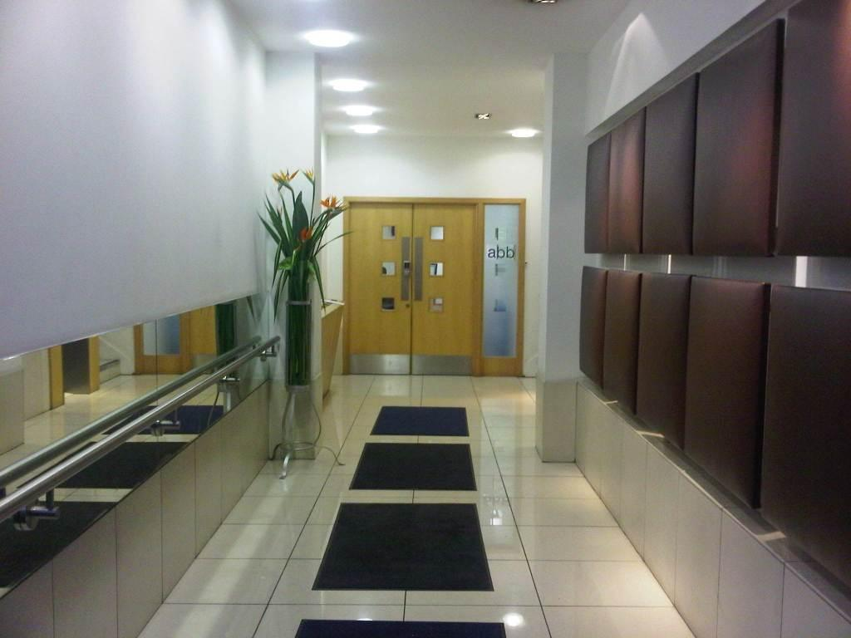
1,290 sq ft (119.8 sq m)
TO BE LET

Description: | Warwick House is situated on the East Side of Buckingham Palace Road opposite the Royal Mews. It is therefore well located for the transport interchange at Victoria (Victoria, District and Circle Underground lines, Mainline Rail, Gatwick Express and Bus station).
Accommodation: | The offices form part of the second floor on the front of the building, overlooking the Royal Mews, comprising a net internal floor area of 1,290 sq ft. The offices have been divided by demountable partitioning to provide three private offices/meeting rooms, an open plan area, comms room and kitchenette.
Amenities: | - Comfort cooling  - Automatic passenger lift  - Plastered ceiling with suspended lights  - Raised floors  - Kitchenette  - Fully fitted offices  - Furniture available if required by arrangement
Lease: | A sublease to expire in March 2014. The lease will be excluded from sections 24 – 28 of the Landlord & Tenant Act 1954 (Part II) as amended.
Rent: | £35.00 per sq ft per annum exclusive
Rates: | The rates payable for 2011/12 equate to approximately £14.92 (in transition)
Service Charge: | The service charge on account equates to approximately £6.30 per sq ft
Viewings: | Strictly by appointment with sole agent Mellersh & Harding:
 | Jonathan Stern  DDI: 0207 522 8517  jstern@mellersh.co.uk | Claire Cadbury  DDI: 0207 522 8542  ccadbury@mellersh.co.uk

